# Endpoint 1:

Status 200

Status 204

Status 500

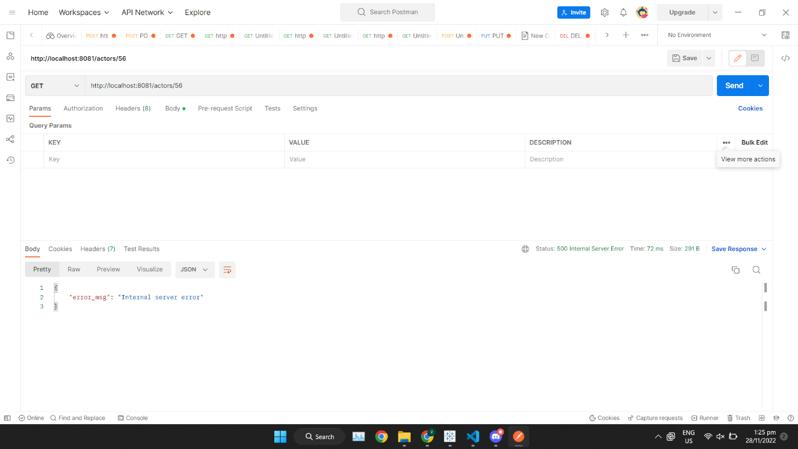

# Endpoint 2:

Status 200

Status 500

# Endpoint 3:

Status 201

Status 500

# Endpoint 4:

Status 200

Status 204

Status 400

Status 500

# Endpoint 5:

Status 200  
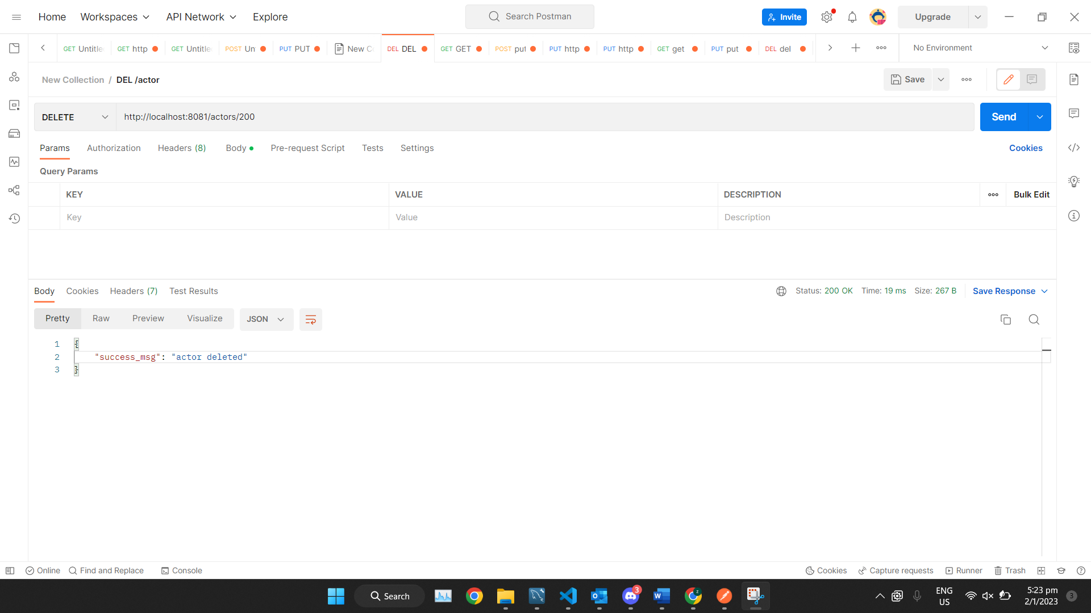

Status 500

# Endpoint 6:

Status 200

Status 500

# Endpoint 7:

Status 500

# Endpoint 8:

Status 201

Status 400

Status 409

Status 500

# Endpoint 9:

Status 201

# 

Status 409

# Endpoint 10:

Status 201

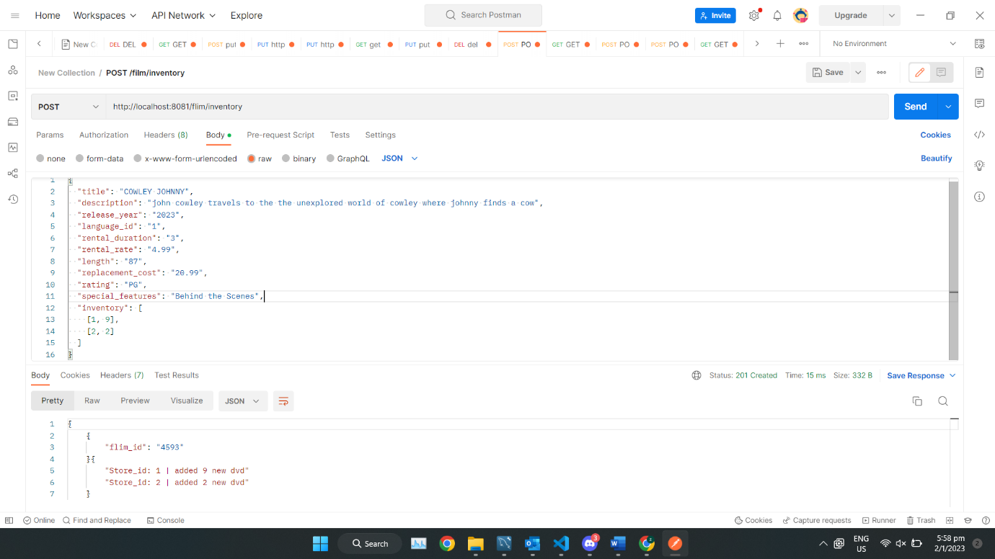

Status 409

